Models | MPS-6015W | MPS-6015L | MPS-6090-120 | MPS-6090-220
Input
Voltage | 220 VAC | 220 VAC | 120 VAC | 220 VAC
Voltage Range | + / - 15%
Frequency | 50 Hz | 60 Hz | 60 Hz | 50 Hz
Protection | Fuse (8A) | Fuse (8A) | Fuse (15A) | Fuse (15A)
Power Factor | ≥ 0.9(full load)
Output
Voltage | 60 VAC | 60 VAC | 60/90VAC, selectable | 60/90VAC, selectable
Regulation | + / - 5%
Waveform | Quasi-square
Current | 15A
Power | 900 VA | 900 VA | 900 VA | 1350 VA
Protection | Current limited
Short Current | 150 % of max. current rating
Efficiency | ≥ 90%
Time Delay Relay
Initialization | 10s (selectable, TDR is an optional feature)
Mechanical
Input Connection(s) | Terminal Block
Output Connection(s) | 5/8" female
Enclosure Material | Aluminum
Finish | Powder coating
Dimensions | 335 x 217 x 190mm
Environmental
Operating Temperature | - 40°C to 55°C
Humidity | 0 to 95% non-condensing

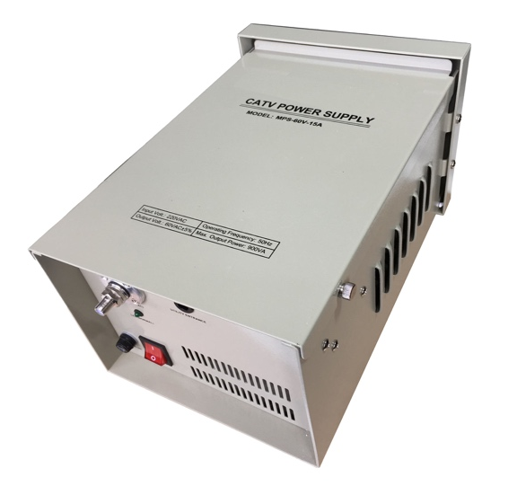

- * Constant voltage ferroresonant transformer
- * Fully regulated, clean and reliable output AC power
- * Input and output protection, lightning surge protection
- * Current limited output and short-circuit protection
- * Automatic restart upon removal of short
- * Field selectable output voltages
- * Powder coated enclosure for outdoor applications
- * Pole & wall mount installations
- * 5/8” female output connection
- * Durable LED indicator
- * Optional Time Delay Relay (TDR)

- More voltage configurations may be available. Please download the datasheet or contact us directly for more details.
- Due to continuing improvements, the product is subject to change without prior notice.



